Friday 9th October 2026
Dear parents and carers,
Thank you to all who attended our Harvest Festival in church yesterday. It was a lovely opportunity for families and the wider community to come together to celebrate the season and give thanks. Two of our House Captains are pictured below with the generous donations for the Didcot Emergency Foodbank— A huge thank you to everyone who donated, your kindness and support are greatly appreciated.
Dear God, thank you for all the yummy food we eat. I give thanks to you for all the workers in the foodbanks donating their time to a good cause. Thank you so much for all the farmers, spending hours a day on a farm growing delicious fruit and vegetables. Thanks for my kind, loving parents who cook my delicious meals. Rudy
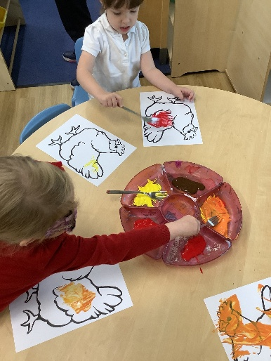
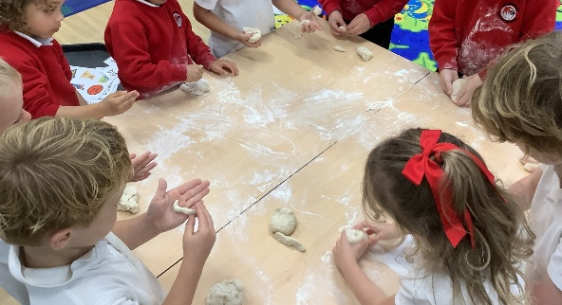
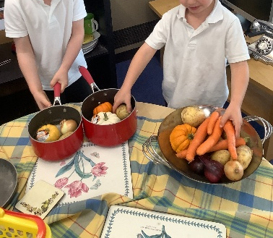
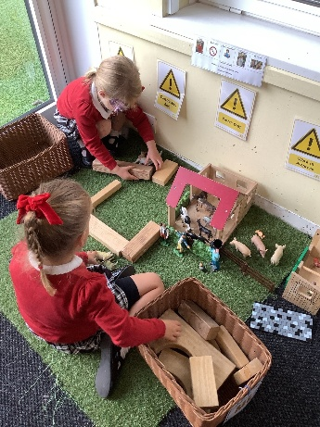
Our learning
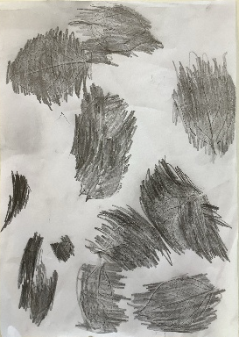
Pupil in O’Keeffe class have been busy leanring about Autumn and Harvest. Activities have included paining, a harvest shop and making harvest mice out of bread.
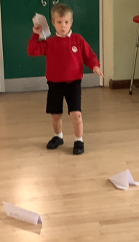
In Goldsworthy class, pupils have been busy learning about aeroplanes as part of their transport topic and have created leaf rubbings in art.
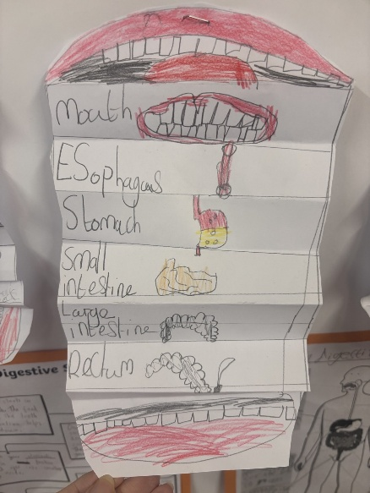
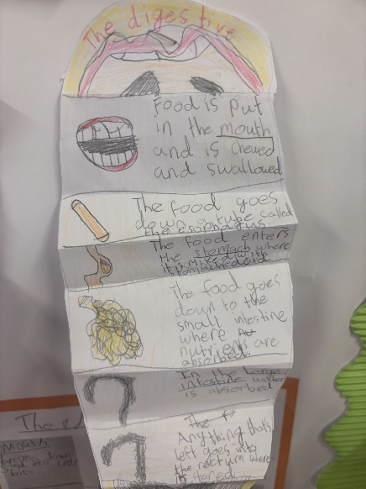
Picasso class have been learning about digestion in Scinece. This week, they conducted an experiment where they used tights to show what happens to food in the intestines! They then created diagrams to record their learning.
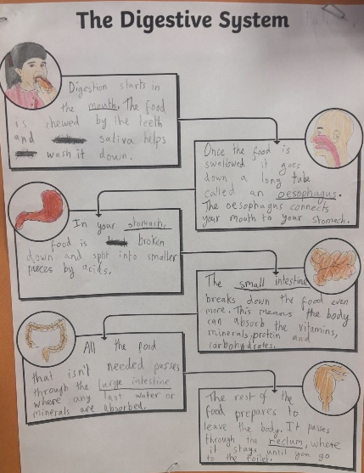

Pantomime
We are thrilled to announce that The Wizard Theatre group are returning to Blewbury School and will be performing their version of Dr Dolittle to our pupils on Thursday 26th November.
This is part of our extra-curricular enrichment offer where we plan to travel to a pantomime every other year and have a theatre group visit the school in the in-between years.
Please make the ticket payment of £6.40 on MCAS.


Clubs
Following our most recent parent survey, we know that many parents would welcome a wider range of clubs and activities for our pupils. Last year, we introduced new Yoga and Computing clubs in response to this feedback; however, unfortunately, pupil numbers were too low for these clubs to run. This year, despite the challenges of limited staffing, we are doing our best to provide a varied offer, with one staff-led club and one Elite Youth Sport (EYS)-led club available each week, alongside our existing wraparound care provision. We are delighted to be offering an EYS-led Football Club and a staff-led Choir Club next half term. We would encourage families to support these opportunities wherever possible, as EYS requires a minimum of 10 pupils to register for a club in order for it to go ahead. Thank you for your continued feedback and support as we work to provide engaging and enjoyable opportunities for all our pupils.

Celebrations
Congratulations to the following children who have received Star of the Week in our celebration assembly:
Arthur for listening and trying his best at carpet time
Amelia. S for becoming more independent and do so many things by yourself
India for always showing our school values
Seb for always being ready to learn
Heidi for being an outstanding role model and consistently demonstrating our school values
Florence for showing great resilience and never giving up, even when things are challenging.
Samuel for exemplary effort in his creative writing
Rory for always giving 100%

House points
331 | 325 | 256 | 371

Yours sincerely,

Miss Reeder.
Headteacher.

Value of the Term: Thankfulness

Important Dates
Friday 9th October | PTA uniform give away
Monday 12th October | Goldsworthy trip to Gaydon Motor Museum
Thursday 15th and Friday 16th October | Bike ability for Banksy class
Tuesday 20th and Thursday 22nd October | Parent/carer and teacher meetings  Invites to book a meeting will be sent via MCAS
Thursday 22nd October | School photo day
Monday 26th October – Friday 30th October | Half Term
31st October | Deadline for Secondary School applications (Year 6 pupils)
Monday 2nd November | ODST staff training day – School closed to pupils
Tuesday 15th and Thursday 18th December, 2.30pm | O’Keeffe and Goldsworthy Nativity
Wednesday 16th December | Christmas jumper and Christmas lunch day
Friday 18th December | School finishes at 1.30pm

2026/2027 Term Dates

