Thursday 16th July 2026
Dear parents and carers,
What a wonderful year it has been! We have shared so many memorable experiences together, and it has been fantastic to see our children grow in confidence, resilience and independence throughout the year. We rounded off the term in style with Banksy Class's brilliant performance of Robin and the Sherwood Hoodies (pictured below), which was a fitting celebration of all their hard work and talent. There have been so many highlights this year, including our theatre trip at Christmas, class visits to Cotswold Wildlife Park, Oxford Castle, Hill End and the Earth Trust, as well as the unforgettable Year 6 residential to Calshot. These experiences have created lasting memories and provided wonderful opportunities for learning beyond the classroom. We would like to wish our Year 6 pupils every success as they move on to the next stage of their journey. We are incredibly proud of everything they have achieved and have no doubt that they will continue to flourish in their new schools.
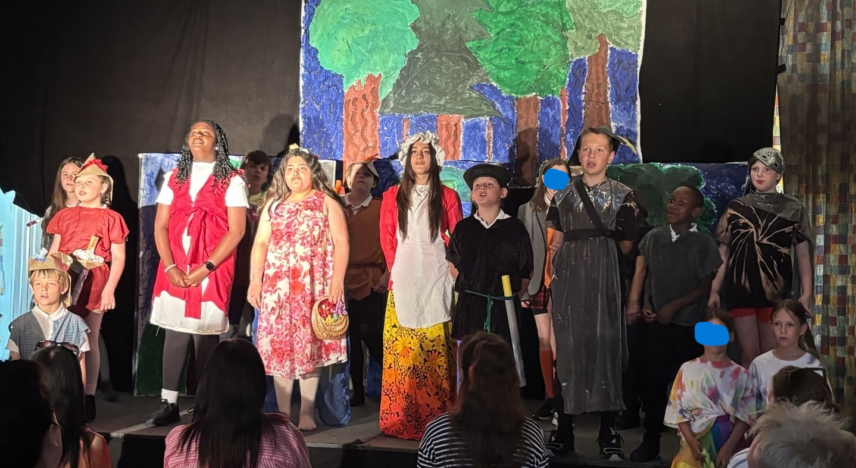
Celebrations
There has been lots to celebrate with our end of year awards:

Congratulations to the following children who received a Star of the Week certificate in our celebration assembly:
- Thandaza for learning multiple roles in the paly to help others
- India for showing great independence in diary writing
- Kingsley M for his enthusiasm in design technology making bread
- Isla A.S for fantastic progress in writing this year

Well done to the following pupils who received a gold award for achieving 200 house-points:
India, Sebbie, Florence, Emilia, Arthur, Myles, Ezmae, Kack, Hector, Aniylah, Reggie.B, Charlie, Amelie, Harlow, Matteo, Rosalie, Kohei, Reggie.C

Congratulations to the following children who were drawn out of the rainbow reading teapot at the end of July and attended our tea party: Rudy, Reggie. B, Hector, Ellie, Bertie, Sebbie, Kiera
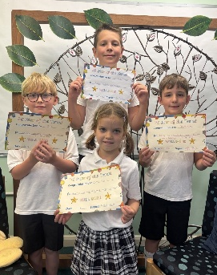
Sports star of the term
- Nina for always having an enthusiastic attitude
- Jack. L for showing enthusiasm and confidence on Sports Day
- Jameson for being an excellent team player and always giving 100%
- Matvii for always being a team player.

The following children received our new Star of the Year award – a huge well done!
- Amelia. W for a fantastic year
- Emilia. V for showing ambition and enthusiasm throughout the year.
- Eliza for consistently showing the school values
- Lily for being an outstanding role model and consistently demonstrating our school values throughout the year.
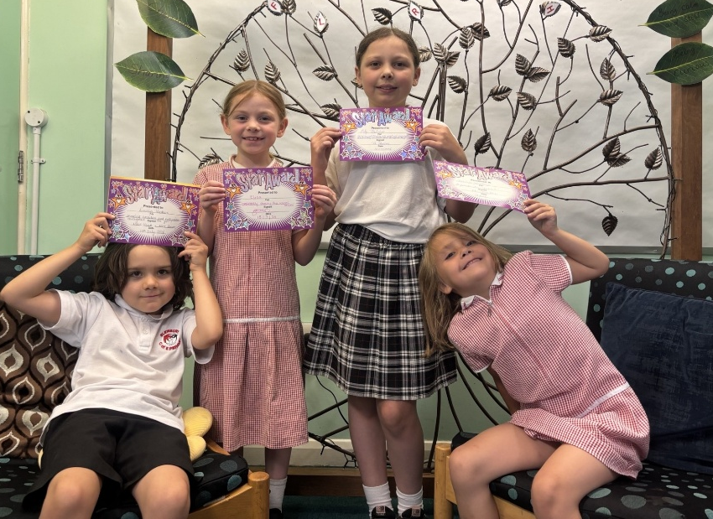

House point totals:
Attenborough | Anning | Hawking | Curie
3132 | 3417 | 3339 | 2924
3rd | 1st | 2nd | 4th

Have a happy, safe and relaxing summer break—we look forward to seeing everyone again in September!

Yours sincerely,

Miss Reeder.
Headteacher.

Value of the Term: Friendship

Important Dates
Thursday 16th July, 1.30pm | Summer Term Ends
Friday 17th July | InSET Day – school closed to pupils
Tuesday 1st September | InSET Day – school closed to pupils
Wednesday 2nd September | InSET Day – school closed to pupils
Thursday 3rd September | New School Year starts for pupil
Monday 26th October – Friday 30th October | Half Term

2025/2026 Term Dates 2026/2027 Term Dates

Community News


HELP WITH ESSENTIALS OVER THE SUMMER HOLIDAYS
If your family lives in Blewbury, Upton or the Astons this local charity can give some financial support if you find you have higher food bills over the holidays or additional needs at this time. From the cost of the weekly food shop, clothing and equipment needed for the new school term, to energy bills, or a one-off payment for essential items, we have funds available to help you.
If you need help, there is a short application form to complete, which can be collected from the North Porch of St Michael’s Church, or you can make a request by emailing us at unitedcharities@outlook.com
We can help you fill in the form so please don’t be reluctant to ask for help, and all applications are totally confidential.
United Charities of the Ancient Parish of Blewbury Registered Charity No: 203538

REST A WHILE
Calling all parents (and maybe grandparents), especially new school parents! After you have dropped your children off to school on that first day of the school year, you are very welcome to stop by at the Vale Room, Blewbury Hall, chat with others and receive friendly support.
Thursday 3rd September - we are open 8.30am - 9.30am and will be serving complimentary refreshments. There is space too for babies and toys for pre-schoolers.
Organised by the local Mothers' Union group.

